CS 255 System Design Document Template

This template lays out all the different sections that you need to complete for Project Two. Each section has guidance to prompt your thinking. You will need to continually reference the interview transcript as you work to make sure that you are addressing your client’s needs. There is no required length for the final document. Instead the goal is to complete each section based on what your client’s needs are. Remove this note when you are finished, and replace all bracketed text with the relevant information.

UML Diagrams

UML Use Case Diagram

UML Activity Diagrams
[You were asked to choose two use cases and create two activity diagrams, one for each use case. Please insert both of your activity diagrams here. Check to make sure that you included appropriate components and symbols and that your design meets the client’s needs.]
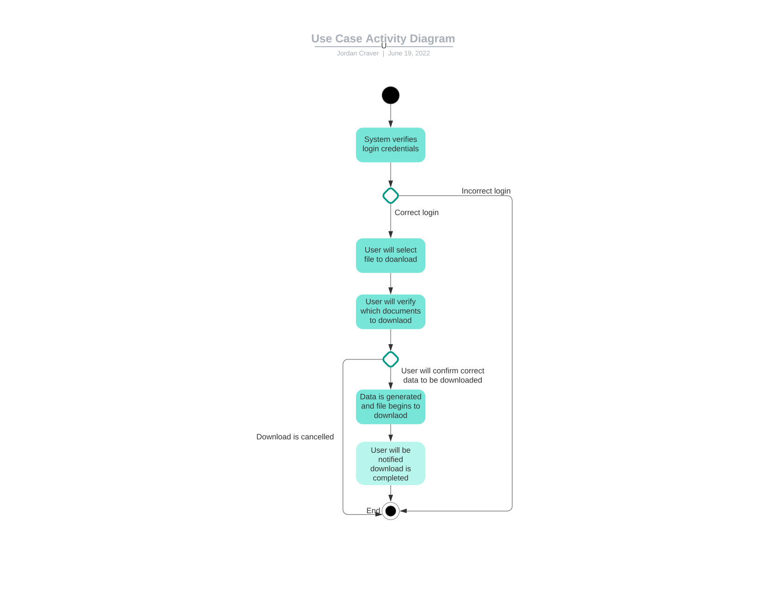
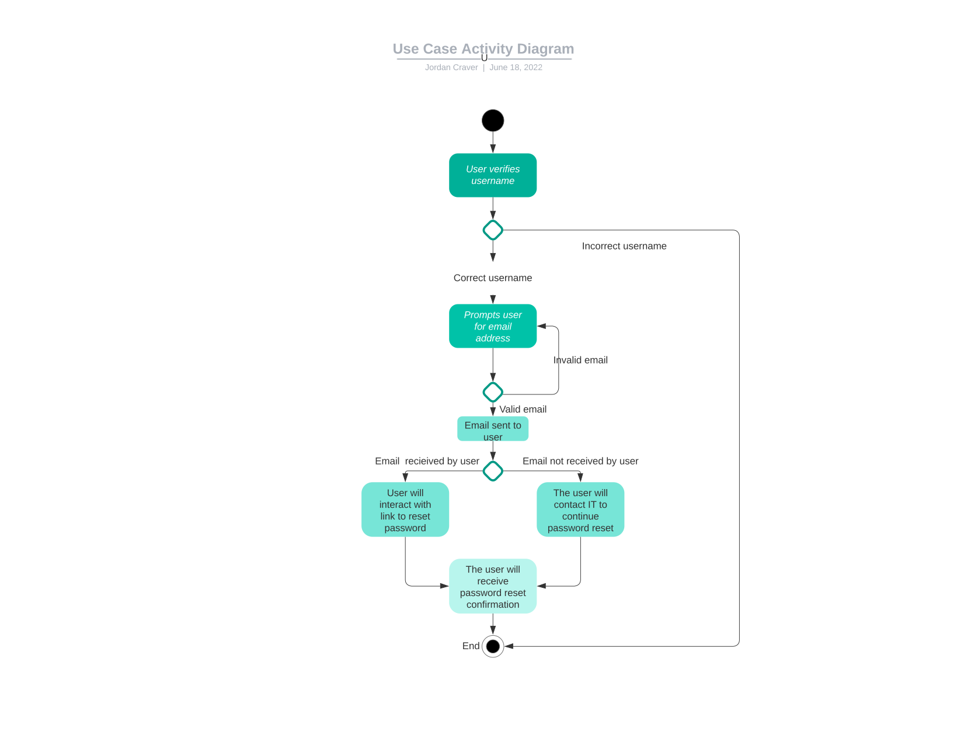

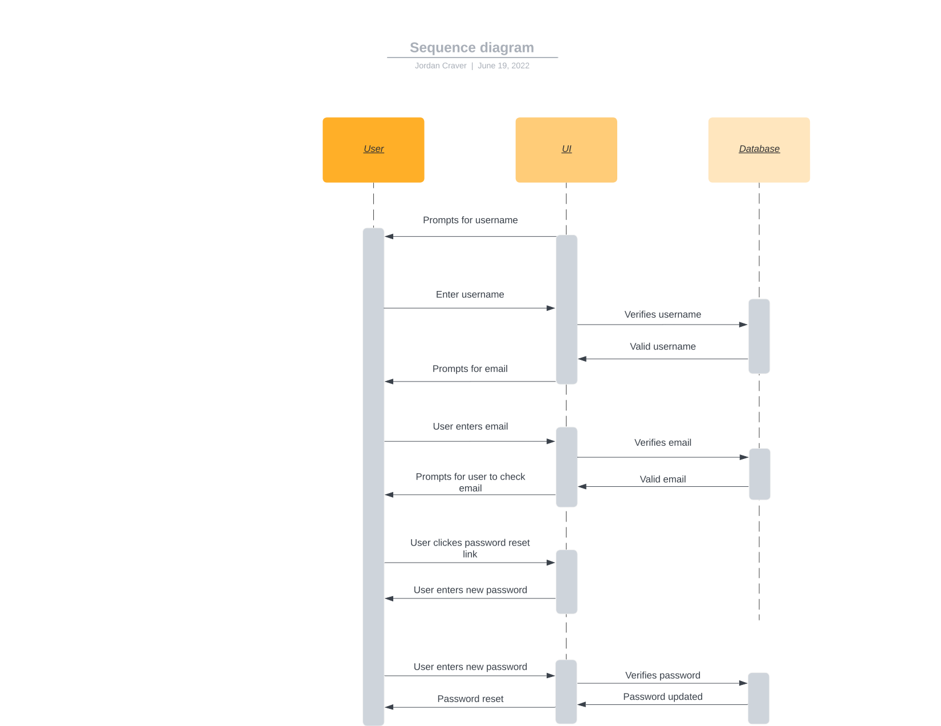
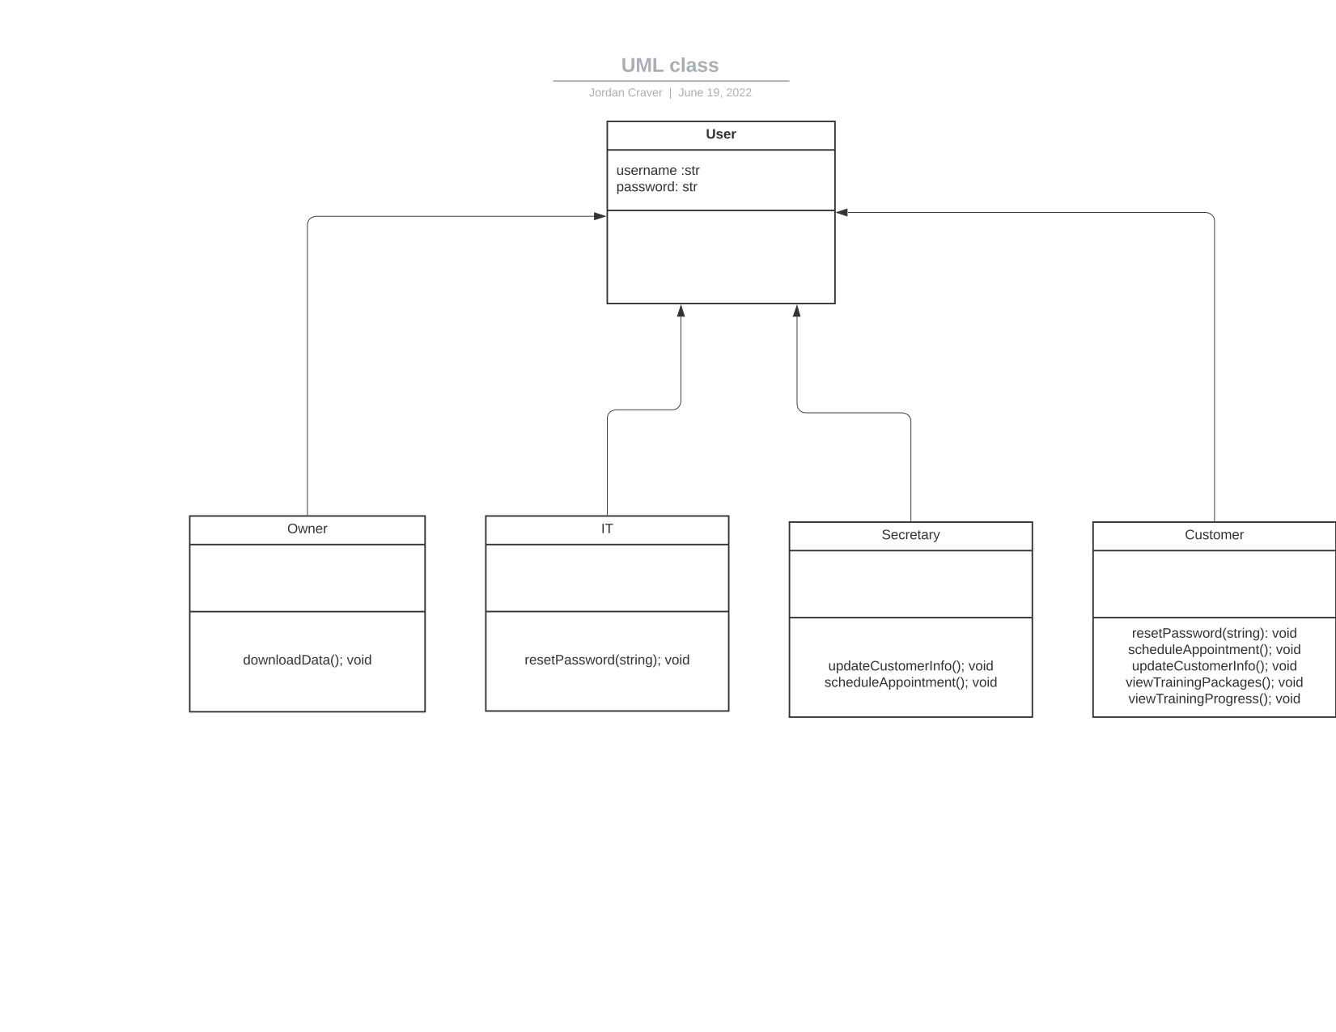
UML Sequence Diagram

UML Class Diagram

Technical Requirements
[Based on the diagrams you have created, describe the technical requirements of your system. These requirements should address the required hardware, software, tools, and infrastructure necessary for your system design.

This seem will have some technical requirements but nothing crazy or drastic that would delay the development of it. The first technical requirement being that with the system being built for web services we would need to make sure it works with cloud services, as well as be mobile friendly. This is critical in being a must do because the client as well as users of the system will need to download and view data and other information while on the go. With that being said we also need database which could be either cloud or traditional. However, cloud is more adaptable and cost efficient for this type of system. The database will be used to store password and customer login information, as well as transactions. Another important factor in this is security and encryption. Any data traveling through the system needs to be encrypted with ssl to protect any and all sensitive information from being compromised. A form of role based access is also needed since there will be different variations of login depending if it is a student, IT tech, or administrator who does so.

